For Immediate Release
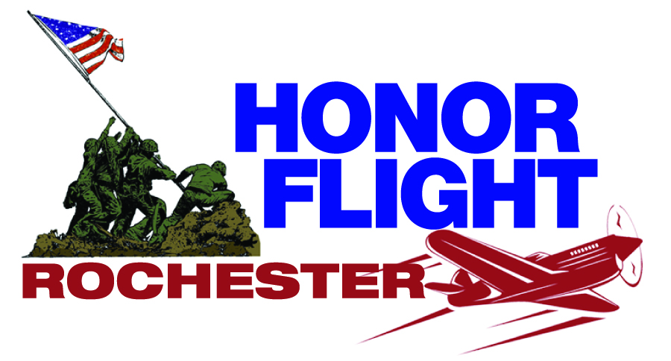

Honor Flight Rochester, Inc.
A “hub” in the national P.O. Box 23581
Honor Flight Network Rochester, NY 14692

Honor Flight Rochester: We Need Veterans for Honor Flights

ROCHESTER, NY – Honor Flight Rochester has taken 2,588 men and women veterans from the Greater Rochester area on 54 well-deserved Honor Flight missions to visit their memorials in the nation’s capital. Thanks to the generosity of the community, Honor Flight Rochester (HFR) is continuing its mission of escorting our veterans on a free Honor Flight.

We want every veteran to experience their Honor Flight. Please help us find all of them so they, too, may go on their missions. The process is simple and begins with the submission of their application.

HFR is looking for World War II, Korean War (1950-53), Cold War (1946-64)* and Vietnam-era veterans to take on an all-expenses-paid Honor Flight mission to Washington, D.C. During the two-day, weekend Honor Flight, we visit the World War II, Korean War, and Vietnam War memorials. We also stop at Arlington National Cemetery and experience the Changing of the Guard at the Tombs of the Unknowns, visit the Women’s Memorial, and see many other memorials. HFR covers the costs of the air fare, hotels, and meals.

“The men and women who answered our country’s call during those tense times are deserving of our admiration,” said HFR Co-founder and Chairman of the Board of Directors Peter J. Glennon, Esq. (Major, Ret. USAF). “They stood their posts in the United States and in foreign lands to preserve freedom. We want to take them on an Honor Flight to thank them for their service.”

“Many former service members feel that because they were not in combat that they aren’t entitled to an Honor Flight. We disagree. We honor them and their service and we want them to fly to Washington, D.C.,” said HFR President Richard Stewart.

To fly, apply. Veterans can apply for an Honor Flight trip online at Honor Flight Rochester.org. Paper Honor Flight applications are available through the U.S. Mail by leaving a voicemail with your name and address at (585) 210-2115. Veteran guardians may also apply on-line at Honor Flight Rochester.org. Or request paper application by the voicemail. (Note: There is a cost associated with being a guardian).

Media Contact:
Richard Meier,
585.315.0564

# # #

Honor Flight Rochester (www.honorflightrochester.org) – one of 131 established hubs in 45 states the national Honor Flight Network – is a not-for-profit, fully-volunteer organization with a goal of taking every World War II, Korean War, Cold-War era or Vietnam War veteran from the Greater Rochester area who otherwise would or could not go, to visit and reflect together at Washington D.C. Memorials built in their honor. The two-day trip is free to all World War II, Korean, Cold-War era, or Vietnam veterans and to veterans of any era who suffer a terminal illness. Rochester’s flying season is April to October. To date, 2,588 men and women veterans have now flown on 54 missions from the Greater Rochester area since the local organization began full scale flights in early 2009.

Honor Flight Rochester. Please Join Us – Generously. All THEY did… was save the world!

