For Immediate Release
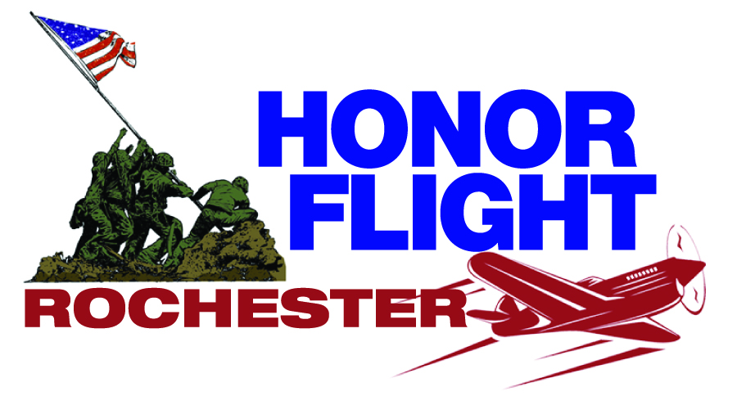
Rick Meier
(585) 315.0564

Honor Flight Rochester, Inc.
A “hub” in the national P.O. Box 23581
Honor Flight Network Rochester, NY 14692

Honor Flight Rochester Names Greg Foust Vice-President of Volunteers
He coordinates the activities of more than 300 volunteers for local organization.

Rochester, NY -- The Honor Flight Rochester board of directors has named Greg Foust as vice president Volunteer Resources.

Foust began volunteering with the Departure and Welcome Home teams in early 2010. Soon after, he joined the Volunteer Resource Committee. He was named to the Honor Flight Rochester Leadership Team in May 2011. Foust flew as a guardian for a veteran on Missions 10 and 25.

Presently he is the Chief Operating Officer for eHealth Technologies; a rapidly growing Rochester-based healthcare services company. Prior to joining eHealth in 2007, he worked at Eastman Kodak Company for 35 years, where he held several senior management positions.

“I have a very special place in my heart for our veterans,” said Foust. “During World War II, my father was a captain on a PT boat in the South Pacific and my father-in-law flew a bomber over Europe. My involvement in coordinating the more than 300 wonderful volunteers associated with Honor Flight Rochester is my way of saying thanks to my dad, my father-in-law and to all veterans who served so honorably and sacrificed so much for all of us.”

"Greg's commitment to volunteerism has greatly benefited everyone at Honor Flight Rochester,” said Honor Flight Rochester President Rich Stewart.

In addition to Honor Flight Rochester, Foust serves on the Board of the Conesus Lake Association, is a Business Mentor with the Young Entrepreneurs Academy and a guest judge for the annual High Tech Rochester business plan competition. Foust also enjoys building sets for the Greece Athena Middle and High Schools musicals.

Foust and his wife Peg live in Geneseo, NY. They have been married for 41 years and have two children and three grandchildren. They enjoy travelling.

HFR has now escorted 1,492 WWII, Korean and Vietnam War veterans from Western NY to visit their Memorials in Washington D.C. HFR resumes taking veterans on an Honor Flight with four missions planned this spring. The first flight is scheduled for April 5-6.

# # #
Honor Flight Rochester. Please Join Us – Generously. All THEY did… was save the world!

*****
Honor Flight Rochester (www.honorflightrochester.org) – one of 100 established hubs in the national Honor Flight Network – is a not-for-profit, fully-volunteer organization with a goal of taking every World War II, Korean War, or Vietnam veteran who otherwise would or could not go, to visit and reflect together at Washington D.C. Memorials built in their honor. The two-day trip is free to all World War II, Korean or Vietnam veterans and to veterans of any era who suffer a terminal illness. Rochester’s flying season is April to October. Honor Flight Rochester has escorted 1,492 veterans to Washington D.C. since the local organization began full scale flights in early 2009.

